# SOP FOR

1. **PURPOSE: Safe Opening & closing of Peephole flanges.**
2. **SCOPE:** **-** Blast Furnace & Accessories.
3. **RESPONSIBILITY: Engineer In charge and workmen on job.**
4. **PROCEDURE: PEEPHOLE FLANGE OPENING & CLOSING.**

**LIST OF TASKS COVERED:**

Activity No 1 : Peephole flange opening.

Activity No 2 : Peephole flange closing

Activity No 3 : Peephole glass replacement.

* ***PPE to be used*** :

       Helmet, safety shoes, dust mask, hand gloves, goggle, apron, face shield

***Aspect / impact***

|  |  |
| --- | --- |
| Dust Generation | Air pollution |

***Hazards identified***

**Mechanical hazards**

* Trapping of hand between the blow pipe flange and peep hole assembly
* Impact
* Entanglement
* Impact of peep hole flange, wedge & pins
* Trapping of leg into the platform opening while working near blow pipe no1 & 14 due to slippage.
* Impact of peep hole flange with air pressure

**Physical hazards**

* Temperature of the blow pipe & burn injury
* Contact with hot coke
* Contact with hot air
* Contact with hot metal /slag
* Burn injury while handling hot items like wedges, front swivel flange

**Chemical hazards**

* Gas poisoning

Behavioral Hazards:

* working without all required PPE’s
* Working under influence of alcohol
* Horse play
* Casual approach
* Not following SOP/WI while carrying out the job

▪ Tools: - Hammer 2 Kg.

**Activity No 1: Peephole flange opening**

1. Take clearance from cast house in charge (Production dept) for peephole flange opening.
2. Backdraft valve in open condition...
3. Bleeder valve in open condition.
4. Person carrying out the activity should wear safety goggle, Apron and hand gloves meant for handling hot objects besides other mandatory PPES’s
5. Push the flange cover handle upwards (by hammering) so that cover gets un locked from its groove.
6. Open the peep hole assembly by standing at one side.
7. Care should be taken to see that the person opening the flange should not stand directly in front of the peep hole.
8. Once peephole flange is opened, check for negative draft through the peephole flange using a suitable loose cloth by holding it near the peephole flange.

DC PEEPHOLE VALVE ASSLY

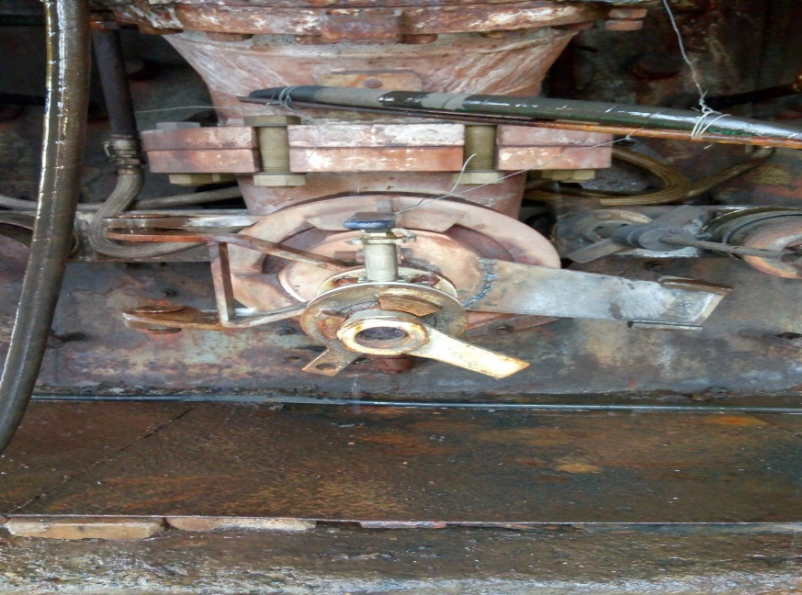

P.Hole Flange Cover Handle

MODIFIED PEEPHOLE VALVE ASSL

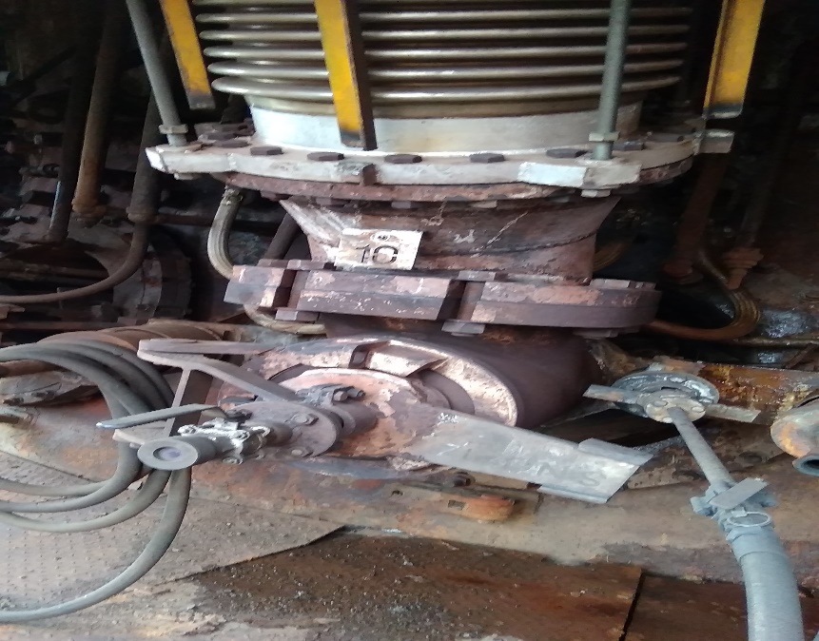

P.Hole Flange Cover Handle

**Activity No 2: Peephole flange closing & peep hole valve replacement**

1. Take clearance from the furnace in charge after opening of tuyeres for peephole flange closing.
2. Backdraft valve in open condition.
3. Bleeder valve in open condition.
4. Person carrying out the activity should wear safety goggle, Apron and hand gloves meant for handling hot objects besides other mandatory PPES’s
5. Clean all the machined surfaces of the peephole assembly, with emery paper. If any unevenness is noticed, replace the flange.
6. Push the flange cover handle downwards (by hammering) so that cover gets locked in the groove.
7. Peep hole valve also can be replaced if required.
8. Give clearance to production dept.
9. Care should be taken to see that the person closing the flange should not stand directly in front of the peep hole.

Activity No 3 : Peephole glass replacement.

1. Take clearance/work permit from the furnace in charge for replacing the glasses.

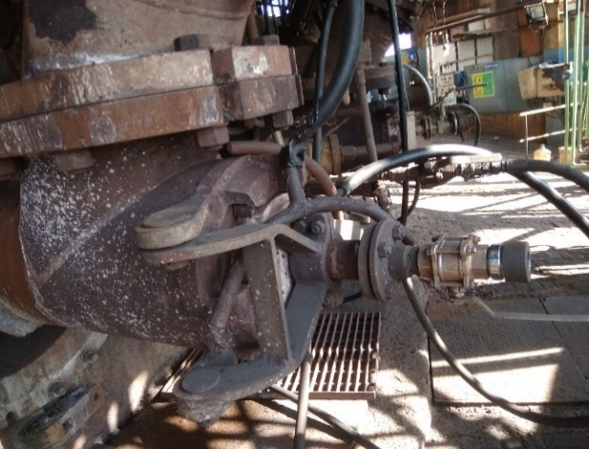

Peephole Ball valve

Glass holder

1. Person carrying out the activity should wear safety goggle, Apron and hand gloves meant for handling hot objects besides other mandatory PPES’s
2. Close the ball valve of peephole in the presence of shift superintendent.
3. Ensure that no leakage of hot blast from valve.
4. Open the glass holder by rotating by hand.
5. Replace the glass & fit the holder.
6. Open the ball valve & check the visibility.
7. Clear the work permit.

**DO**

* Wear proper hand gloves that are meant for handling hot items.
* Wear safety goggle apart from mandatory PPE’s.
* Align the flange to center for proper visibility.
* Ensure that no workmen /supervisor is standing in the way of peephole flange.

**DO NOT** :

Stand in front of the inspection peep hole while opening.

**Amendement Record**

|  |  |  |  |
| --- | --- | --- | --- |
| **Date** | **Manual Section Ref. & Para** | **Brief details of Revision** | **New Rev.** |
|  |  |  |  |
|  |  |  |  |
|  |  |  |  |

|  |  |  |
| --- | --- | --- |
| **Prepared By:**  Digital head VAB | **Reviewed & Issued By:**  Management Representative | **Approved By:**  Mechanical and Asset Integrity Head VAB |
| **Signature:** | **Signature:** | **Signature:** |
| **Review Date: 06.06.2023** | **Review Date: 06.06.2023** | **Review Date: 06.06.2023** |